\\uselsfp0002\shared\Space, Range & Display\Utils\RPAS Client\CD\Disk1

Run setup.exe

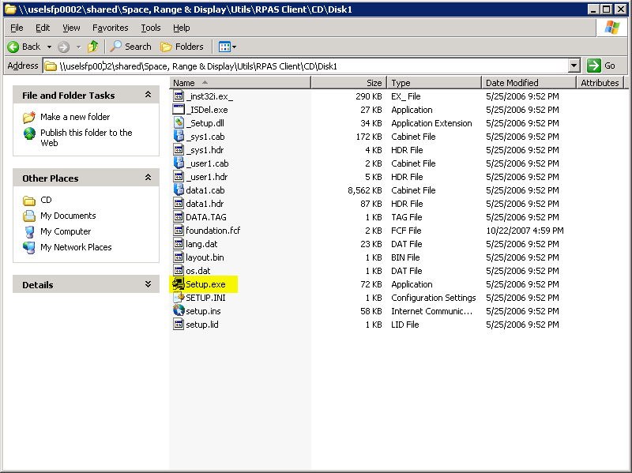

Ignore this window, we will go back to this later

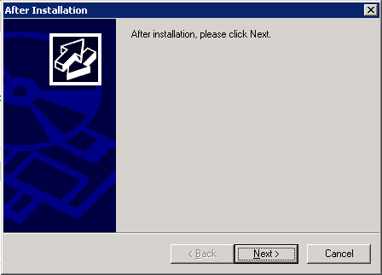

Click Next

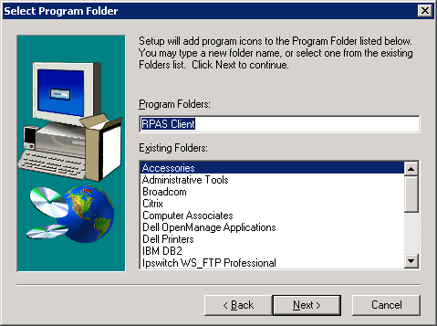

Click Next

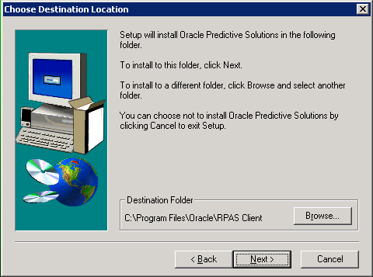

Click Next

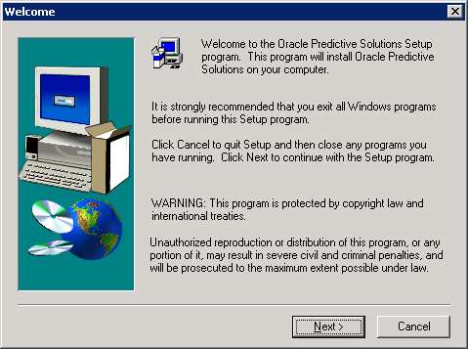

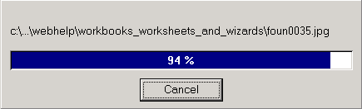

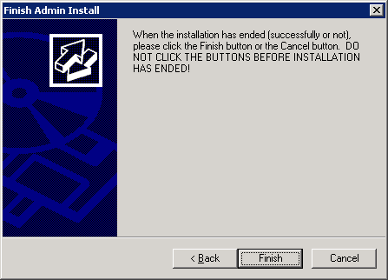

Start the application – Oracle Predictive Solutions

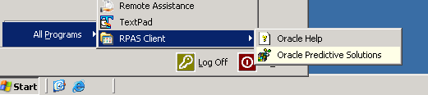

and this error would appear.

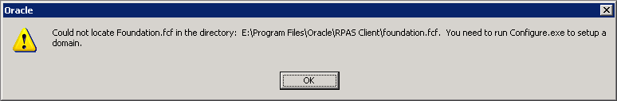

Copy the foundation.fcf file from the install folder to the root folder of the Oracle\Rpas Client folder (where the application was installed)

Start the application again and the login window will now appear
